History Graduate Students are the best TAs on Campus! History Graduate Students are the best TAs on Campus! History Graduate Students are the best TAs on Campus! History Graduate Students are the best TAs on Campus! History Graduate Students are the best TAs on Campus! History Graduate Students are the best TAs on Campus! History Graduate Students are the best TAs on Campus! History Graduate Students are the best TAs on Campus! History Graduate Students are the best TAs on Campus! History Graduate Students are the best TAs on Campus! History Graduate Students are the best TAs on Campus! History Graduate Students are the best TAs on Campus! History Graduate Students are the best TAs on Campus! History Graduate Students are the best TAs on Campus! History Graduate Students are the best TAs on Campus! History Graduate Students are the best TAs on Campus! History Graduate Students are the best TAs on Campus! History Graduate Students are the best TAs on Campus! History Graduate Students are the
Department of History
University of British Columbia
History Graduate Students are the best TAs on Campus! History Graduate Students are the best TAs on Campus! History Graduate Students are the best TAs on Campus! History Graduate Students are the best TAs on Campus! History Graduate Students are the best TAs on Campus! History Graduate Students are the best TAs on Campus! History Graduate Students are the best TAs on Campus! History Graduate Students are the best TAs on Campus! History Graduate Students are the best TAs on Campus! History Graduate Students are the best TAs on Campus! History Graduate Students are the best TAs on Campus! History Graduate Students are the best TAs on Campus! History Graduate Students are the best TAs on Campus! History Graduate Students are the best TAs on Campus! History Graduate Students are the best TAs on Campus! History Graduate Students are the best TAs on Campus! History Graduate Students are the best TAs on Campus! History Graduate Students are the best TAs on Campus! History Graduate Students are the

TEACHING
ASSISTANT
HANDBOOK

TABLE OF CONTENTS

PEOPLE TO KNOW 2

GENERAL POLICIES AND PROCEDURES 3

IMPORTANT CALENDAR DATES 7

BEING APPOINTED AS A TEACHING ASSISTANT 8
Should I always be a TA?

TEACHING ASSISTANTS’ RESPONSIBILITIES 9
How many hours do I work?

TA Workload Summary Form 10

ASSESSING STUDENTS’ WORK 11
Grade ranges
Sample marking rubric

ACADEMIC INTEGRITY 14

PROFESSIONALISM 16
EVALUATION OF TEACHING ASSISTANTS 17

OTHER TEACHER TRAINING RESOURCES AT UBC 18

ACADEMIC AND PERSONAL COUNSELING FOR STUDENTS 20

PEOPLE TO KNOW

Role | Name | Relationship to Teaching Assistants
Graduate Chair | Please check Department website for current Graduate Chair: Faculty Link | - Oversees the History graduate program  - Advises and answers questions from graduate students regarding academic matters.
Department Head | Please check Department website for current Department Head: Faculty Link | - Signs Grade Change Forms  - Advises TAs regarding any threatened job actions
Teaching Assistant Director | Please check Department website for current TA Director: Faculty Link | - Organizes the TA Workshop Series for new Teaching Assistants.  - Serves as mentor for TAs.  - Assigns Teaching Assistants for the academic year. Resolves scheduling conflicts.  - Advises and answers question from graduate students regarding TA matters.
Course Professor(s) | Please check Department website: Faculty Link | - Fills out TA workload summary.  - Meets with TA to review TA workload summary form: defining the TAship roles and responsibilities.
Graduate Program Assistant | Jason Wu  hist.grad@ubc.ca | - Maintains TA administrative database of:  - TA workload summaries  - TA appointment letters  - HR appointment forms  - Distributes TA postings  - Assigns TA Office/Enables student card access to office.  - On SISC, links TA with designated course and online course material (CANVAS).
Department Administrator | Jocelyn Smith  jocelyn.smith@ubc.ca | - Answers questions regarding payrolls/direct deposit/payslips/benefits
Front Desk Administrator | Timothy Tan  history.dept@ubc.ca | - Sets up TA mailboxes in the main office.
Please check Department Website for contact information:
GENERAL POLICIES AND PROCEDURES

Pay Rates: TA pay rates are negotiated by the TA Union (CUPE 2278) and the current pay rates can be found on the CUPE 2278 website: https://cupe2278.ca/how-we-help/pay-rates/. Your TA pay will always represent the current rates on the website.

TA payments (via direct deposit) are issued / deposited on the 15th and last day of each month. After the graduate program assistant has set up the teaching assistantship on the Human Resources System (Workday), TAs will receive email notifications from Workday to fill out a direct deposit form as part of their Human Resources online onboarding process.

Payslips: UBC Payroll payslips are posted online each pay period; please check regularly to ensure that you are being paid the correct amount. To view payslips, log into the UBC Virtual Private Network (visit http://www.it.ubc.ca/security/VPN.html for details) and then into the UBC Management Systems portal using your CWL login at https://irp.ubc.ca/. If you are not being paid, or you are being paid an incorrect amount, notify the graduate program assistant (hist.grad@ubc.ca) or department manager.

TA Offices:
The History Department TA Offices are located at:
Rooms 143, 145, 147, 149
Auditorium Annex A
1924 West Mall V6T 1Z2

Map: http://www.maps.ubc.ca/PROD/index_detail.php?locat1=45 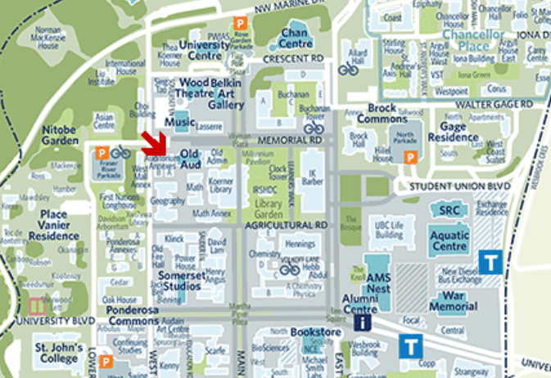
History TA Offices:
Rooms 143,145,147,149
Auditorium Annex A
1924 West Mall V6T 1Z2

TA Office assignments: TA Office Assignments will be assigned by the graduate programme assistant and posted prior to the start of each term on the TA Resource Page. The graduate programme assistant will enable your UBC student card to access the rooms via a swipe card sensor.

Important Notes about TA Office:
- Everybody’s UBC Card serves as the swipe key for:
- 143A (Entrance)
- 143 (Access to Fridge)
- Each TA is assigned to one of four TA Offices.
- Each office shares 12 TAs per term.
- TAs work out their office hours with the other TAs in the shared room. Please consult with other TAs in your shared office to make sure that your hours do not overlap.
- TAs are assigned a primary/designated room, but have access to all rooms in case there are unforeseen circumstances (For example, a TA can use an adjoining empty room to meet with their students if their designated room is temporarily occupied by another TA.
- TA offices are to be used primarily for Office hours (meeting with students from tutorial sections) since this represents the only office space to hold these meetings. Offices not being used for office hours may be used for TA prepping, marking, only if they are not needed for meeting with students.
- Due to close proximity with other student offices, please be respectful of noise. Casual conversations should take place outside of the office area.
- For quiet study, students should use the graduate student lounge. Students can use the TA offices for quiet study if they are not in use, but please recognize that TA-related activities take priority, even TA meetings arranged outside of office hours.

TA Office hours: TAs are required to schedule weekly office hours, to give email notice to the graduate program assistant (hist.grad@ubc.ca) and their instructor for inclusion on the syllabus. Your professor will fill out the amount of office hours on your TA Workload Summary form.

First week of classes: Although some students believe that, like labs, discussion groups don’t meet until the second week of classes, all discussion groups run as usual in the first week. Please note that lectures do not meet on the first Tuesday in September because of the Imagine UBC event for first-year students.

CANVAS: CANVAS represents the professor’s online resource material for the course. TAs will have access to the course’s CANVAS material once their teaching assistantship is set up in the Human Resources system and the graduate program assistant has assigned the TA to the course on the SISC registration system. Once the TA is setup on the system, CANVAS (online course) materials can be accessed at https://faculty.canvas.ubc.ca/ .

Class Lists: TA access to the tutorial class lists will be available once the TA Workload Summary form is submitted to the graduate program assistant. The TA workload summary form is filled out by the professor and indicates the assigned tutorial sections. Once the graduate program assistant receives the TA workload summary, the TA will be assigned to each tutorial section on the SISC registration system. Once the TA is set up on the system, TA access to class lists can be accessed at https://ssc.adm.ubc.ca/fsc/home .

Preparation and duplication of course materials: Please consult with your instructor.
UBC Employee email address: “@ubc.ca” or “@mail.ubc.ca”

As employees of UBC, TAs are required to use a UBC Faculty and Staff email (FASmail) address (“@ubc.ca” or “@mail.ubc.ca”) to communicate with students in their tutorial sections. When emailing your class as a group, keep student privacy in mind by using the blind carbon copy function (“bcc”) or equivalent in your email program. Do not use personal email (E.g. gmail, hotmail, etc.) to communicate with students.

Once the TAship is set up in the UBC HR system, students will receive an automated email with instructions to set up a “@ubc.ca” email. Only UBC employees are allowed to use this email address. Please note that the “@ubc.ca” email will only be accessible during the job (TA) appointment.

Important Note: When students are no longer active employees, their access to FASmail will be automatically discontinued. UBC Faculty and Staff Email (FASmail) is meant to only be used by UBC employees. For academic work, students should be using the UBC student email: (at)student.ubc.ca.

How to extend the use of “@ubc.ca” email after job appointment is finished:

Student Employees who would still like to use the “ubc.ca” email after their job appointments have finished will need to ask their thesis supervisor to sponsor them for a guest email account for a limited period.

- Student must ask thesis supervisor to sponsor guest account. Students will need to be sure that their thesis supervisor knows the student’s CWL name (just the name, not the password).
- Instructions for supervisor on “How to Sponsor a Guest Account” is found on the website:
https://it.ubc.ca/services/accounts-passwords/campus-wide-login-cwl/how-sponsor-guest
- Use the option to “Sponsor an account with an existing CWL”
- Students will need to be sure that their thesis supervisor knows the student’s CWL name (just the name, not the password).

TA Training Program: All new History TAs are required to participate in the History Department’s TA Training Program. The training hours count toward your TA employee hours. The TA Training program represents a series of workshops organized by the TA Director.

Five training courses are required to be completed by all UBC TAs. Here are the courses, with weblinks to complete the training:
- New Worker Safety Orientation
- Preventing and Addressing Workplace Bullying and Harassment Training
- Workplace Violence Prevention Training
- Privacy & Information Security—Fundamentals Part 1
- Privacy & Information Security – Fundamentals Part 2
You are expected to complete this training within your first month of employment. You can count 30 minutes of paid time for each training program that you complete up to a maximum of 2.5 hours (you should ensure these hours are recognized by the course instructor and noted on the Allocation of Hours form). Note: if you have already completed any of these training courses, you do not need to complete them again and you will not be paid to retake the course(s). The online training only needs to be completed once.
Classroom technology: Most discussion groups are held in classrooms with audio/visual equipment. Email classroomservices@students.ubc.ca if you would like an in-person demonstration. If your room lacks A/V equipment, you can either request a different classroom through Classroom Services or borrow equipment through Arts Audio Visual Services (Buchanan C113; av@mail.arts.ubc.ca; 604.822.6516).

TA absences: If you must miss a class, please arrange for another graduate student to substitute (a larger classroom that can accommodate two discussion groups can be arranged), and advise your instructor of the change.

Exams: Three-hour final exams take place in the regular exam periods laid out in the calendar (including Saturdays). TAs are expected to mark their exams and submit grades within 7 calendar days.

IMPORTANT CALENDAR DATES

Please see the UBC Calendar Link for the Vancouver Academic Calendar:
http://www.calendar.ubc.ca/vancouver/
http://www.calendar.ubc.ca/vancouver/academicyear.cfm
Sample Screenshot:
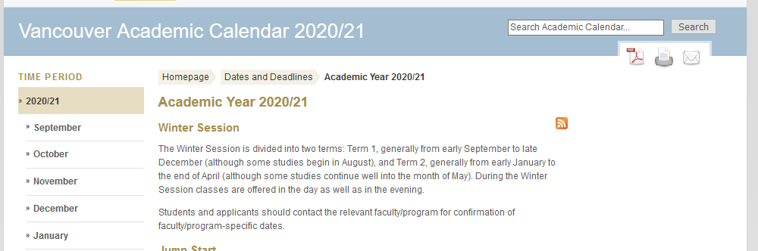

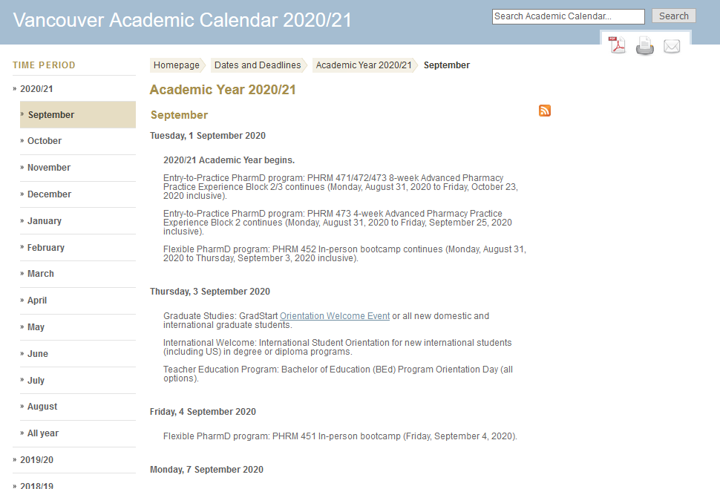

BEING APPOINTED AS A TEACHING ASSISTANT

Placement: In selecting graduate students to be TAs, the TA Director will follow the regulations set by TA Union collective agreement and try to ensure that all students have some opportunities to teach. Because of limits in the number of assistantships that the department can offer in any given year, teaching is assigned according to a standard priority list. Factors that determine this list include external funding, status in the PhD or MA program, previous teaching experience, and course schedule. When candidates for a TA position come from outside the department, the instructor should be consulted regarding the choice of whom to appoint.

Reappointment: The collective agreement states that preference for a student enrolled in a Masters’ program shall be for two (2) teaching years commencing with the start date of their Masters’ program; preference for a student enrolled in a doctoral program shall be for five (5) teaching years commencing with the start date of their doctoral program. Reappointments are contingent upon satisfactory performance of GTA duties; they are also contingent upon placement on the priority list. If you are already in the TA pool and have not completed the 4 or 8 terms of teaching allowed by the collective agreement you will always be selected first followed by those entering the program. If you complete a full roster of TAs or receive funding in excess of $20,000/year you probably should not expect to be reappointed. Places do occasionally open up, notably in other programs and departments, to which you are welcome to apply.

Leaves of absence: If you wish to take a leave of absence or suspend your TA duties, you should speak to the TA Director as soon as possible so that arrangements can be made for your replacement and return.

TEACHING ASSISTANTS’ RESPONSIBILITIES

Should I always be a TA?

There may be times in your graduate career when teaching has a lower priority than your other academic work. Here are some suggestions for determining whether a TA is right for you:

- If you are an MA student and want to complete your degree in two years, you might find it useful to take an extra course instead of teaching in a given term.

- If you are applying to PhD programs, you may need time to prepare applications, visit prospective schools, and contact possible supervisors. The same is true for job applications.

- Many faculty members fund research assistantships. These provide work in specific areas, contact with faculty, and opportunities for travel and publication.

- Completing your degree in good time and submitting articles for publication will mean more to job prospects than a full roster of teaching assistantships.

Attend orientation and lectures: As a TA you must attend a) Teaching Assistant orientation and pedagogy workshops, b) all lectures for the course to which you are assigned, and c) any meetings called by the instructor to plan class discussions, essay assignments and examinations.

Lead Discussion Groups: In first- and second-year courses, you will teach one 50-minute discussion meeting per week for each group to which you are assigned. Use your first class to get to know students, get email addresses, and answer questions about reading lists, participation grades, course expectations, etc. In later classes, you can hold discussions, organize presentations, do short free-writing exercises, or any other activities that you think will help the students to understand the material and succeed in the course. Some possibilities will be discussed during the teaching assistant workshops. Upper-year courses will not generally have scheduled discussion groups, though they might. The TA and the instructor will develop the format and pedagogical orientation of the course together.

Meet with students: You need to hold one regularly scheduled office hour per week and on occasion students may contact you via email in lieu of coming to office hours. Be careful how much time you devote to answering emails and about the content of your emails. Keep copies of emails to and from students in case a problem arises. You also need to make students aware that your email time is limited as well as what kinds of email are appropriate.

Mark essays and other assignments: TAs mark all essay assignments during the term for their discussion groups. Marked assignments are usually returned within two weeks.

Invigilate exams: Final exams for undergraduate courses take place in December and April. Invigilation hours are determined by the course professor filling out the TA workload form. If you are required to invigilate exams (as determined by your TA workload form), you should arrive to the exam site thirty minutes before the exam begins to help prepare the room.

In the middle of each term, when the exam schedule is released, the TA invigilation schedule will be created (based on each TA workload form) and sent out to the TAs. If you cannot invigilate at the assigned time/day, arrange a trade with another graduate student and notify the TA director and instructor. Lateness or failure to show up at your scheduled exams is considered “unsatisfactory performance of duties” and may affect your reappointment possibilities in the Department, or result in your assignment to addition invigilation duties in a subsequent term. Do not make your travel plans until exam assignments have been finalized.

Grade exams: TAs mark final exams, assign participation grades, and submit final grades to the instructor. Final grades must be determined within 7 days of the exam.

Maintain a professional demeanour: TAs should always keep in mind that, in and out of the classroom they are professionals representing the university.

TA WORKLOAD SUMMARY FORM
How many Hours do I work?

The Collective Agreement stipulates that TAs should not work more than an average of twelve hours per week over the 16-week term, for a total of 192 hours. TAs should, however, remember to save some time to invigilate and mark the exams after the term is over. The TA Union recommends that TAs keep track of their hours; this is useful in the event of a strike or a contract re-negotiation.

At the start of each term, Instructors are required to fill out a TA Workload summary form, review this with the TA, and submit a copy to the graduate program assistant (hist.grad@ubc.ca).

Teaching Assistants are under contract to work for 384 hours per 6 credit course (or 192 hours per 3 credit course). This averages out to approximately 12 hours per week over the course of the two terms. All instructors are required to fill out the “Anticipated Workload Summary” and meet with their TA(s) to discuss the workload expectations. This TA Workload form is very helpful for TA(s) as they try to balance the demands of teaching (often for the first time), coursework, and thesis research. It will also help to avoid conflicts and misunderstandings regarding TAs’ contractual obligations.
Professor’s can download the latest version of the TA Workload summary form from the TA Resource Page: https://history.ubc.ca/graduate/ta-resource-page/

Sample screen shot of TA Workload Summary:
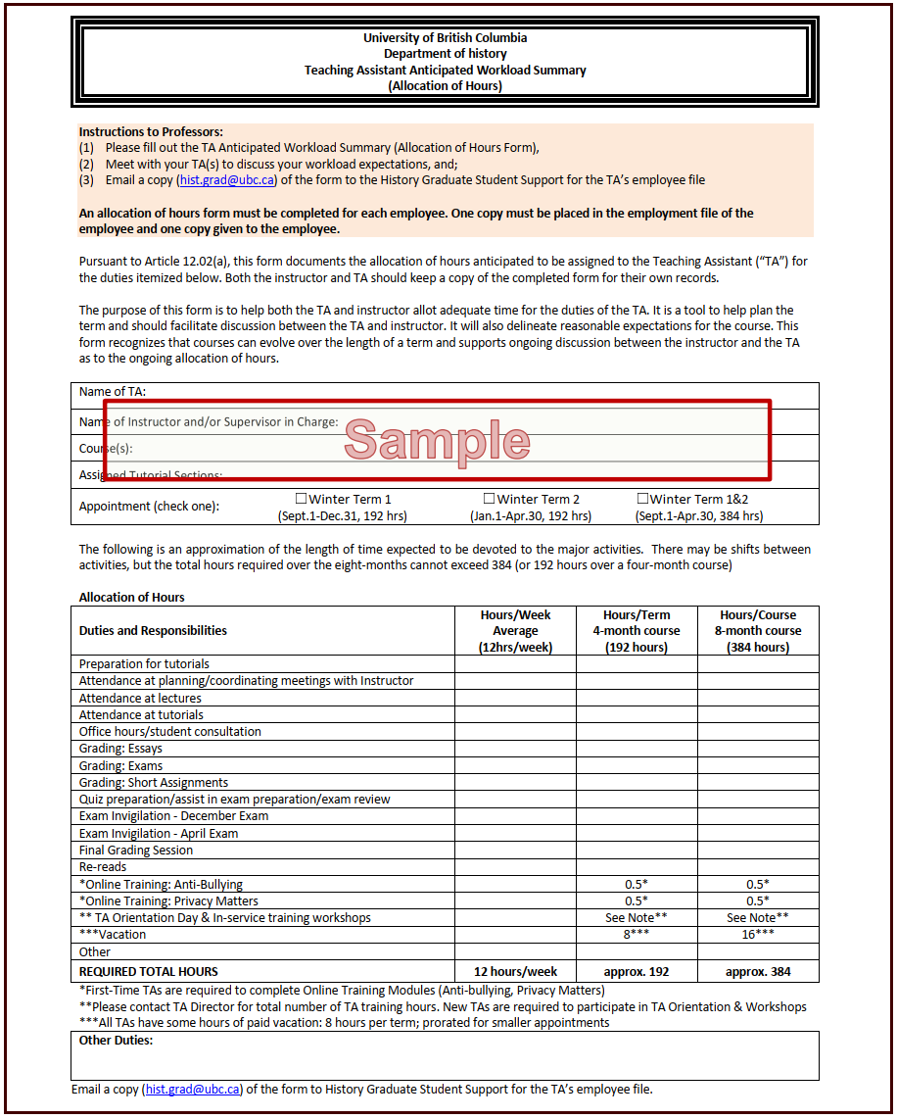

ASSESSING STUDENTS’ WORK

Submitting essays: Have students include their full name, student number, course number, section number, and your name on the cover page of their assignments. Policies on late essays should be presented to students in writing in consultation with your instructor; often they will be listed in the syllabus. If they are not, then please ask your professor what his/her policy is. Please note that students should not engage the office staff when turning in assignments in the Main Office, and that they should turn in assignments directly to your mailbox. We do not date-stamp assignments. Some instructors prefer that assignments be submitted electronically, so make sure you understand the rules that apply to your course.

Assigning grades: Make sure that you understand the grading policy for each assignment within the course. What should the assignment be graded out of? What should the median average be? Do not to assign split grades (e.g. A-/B+).

Recording and submitting grades: Please consult with your instructor about her or his system for recording grades.

Attendance: Keep attendance records for all of your discussion meetings and, if possible, lectures in order to determine the participation grade. If you find that a student is consistently not attending class, you may choose to have the student contacted by the instructor. If a student skips a substantial number of classes, you may wish to consult the faculty member teaching your section about invoking the course’s attendance policy as stated in the course syllabus.

Students with disabilities: The student should register with Access and Diversity in Brock Hall, who will then send you a letter outlining the appropriate accommodations for the student. A&D is known for being very concerned about deadlines, especially around exam paperwork, so you might remind first-year students to keep on top of that.
GRADE RANGES

Letter  Grade | Out of 100(%) | Out of 70 | Out of 50 | Out of 30 | Out of 25 | Out of 20 | Out of 15 | Out of 10 | Out of 5
A+ | 90 - 100 | 63 - 70 | 45 - 50 | 27 - 30 | 22.5 - 25 | 18 - 20 | 13.5 - 15 | 9 - 10 | 4.5 - 5
A | 85 - 89 | 59.5 - 62.3 | 42.5 - 44.5 | 25.5 - 26.7 | 21.25 - 22.25 | 17 - 17.8 | 12.75 - 13.35 | 8.5 - 8.9 | 4.25 - 4.45
A- | 80 - 84 | 56 - 58.8 | 40 - 42 | 24 - 25.2 | 20 - 21 | 16 - 16.8 | 12 - 12.6 | 8 - 8.4 | 4 - 4.2
B+ | 76 - 79 | 53.2 - 55.3 | 38 - 39.5 | 22.8 - 23.7 | 19 - 19.75 | 15.2 - 15.8 | 11.4 - 11.85 | 7.6 - 7.9 | 3.8 - 3.95
B | 72 - 75 | 50.4 - 52.5 | 36 - 37.5 | 21.6 - 22.5 | 18 - 18.75 | 14.4 - 15 | 10.8 - 11.25 | 7.2 - 7.5 | 3.6 - 3.75
B- | 68 - 71 | 47.6 - 49.7 | 34 - 35.5 | 20.4 - 21.3 | 17 - 17.75 | 13.6 - 14.2 | 10.2 - 10.65 | 6.8 - 7.1 | 3.4 - 3.55
C+ | 64 - 67 | 44.8 - 46.9 | 32 - 33.5 | 19.2 - 20.1 | 16 - 16.75 | 12.8 - 13.4 | 9.6 - 10.05 | 6.4 - 6.7 | 3.2 - 3.35
C | 60 - 63 | 42 - 44.1 | 30 - 31.5 | 18 - 18.9 | 15 - 15.75 | 12 - 12.6 | 9.0 - 9.45 | 6 - 6.3 | 3 - 3.15
C- | 55 - 59 | 38.5 - 41.3 | 27.5 - 29.5 | 16.5 - 17.7 | 13.75 - 14.75 | 11 - 11.8 | 8.25 - 8.85 | 5.5 - 5.9 | 2.75 - 2.95
D | 50 - 54 | 35 - 37.8 | 25 - 27 | 15 - 16.2 | 12.5 - 13.5 | 10 - 10.8 | 7.5 - 8.1 | 5 - 5.4 | 2.5 - 2.7
F | 0 - 49 | 0 - 34.3 | 0 - 24.5 | 0 - 14.7 | 0 - 12.25 | 0 - 9.8 | 0 - 7.35 | 0 - 4.9 | 0 - 2.45

A SAMPLE GRADING RUBRIC

Creating a form like this can make your marking process go much faster; instead of writing the same comments over and over on students’ papers, you can simply circle comments. This also gives the student a good visual representation of the mark they received.

Student Name: Mark:

 | Low Grade  (C- and below) | Medium Grade  (B+ to C) | High Grade  (A- and higher)
Argument | No clear thesis statement; only a summary of sources  Doesn’t address significant parts of the assignment  Thesis contradicts evidence chosen  Paper goes off-topic  Organization is confusing  Too long / too short | Thesis statement is not integrated into paper  Thesis statement is there, but is vague and/or not particularly strong  Addresses most, but not all, parts of the assignment  Thesis doesn’t provide “road map” to paper’s contents | Thesis is strong, matches the evidence, and is integrated into the paper  Clear “road map” is present  Addresses all parts of the assignment directly
Evidence | No textual evidence (quotations) are used; evidence is only paraphrasing  Citations inconsistent, incomplete, or in wrong style  Evidence doesn’t match thesis | Uses quotations from the text, but they are not framed well  Confuses paraphrasing and quotation  Evidence presented merely as lists, with little analysis  Citations mostly consistent and complete | Quotations used and framed appropriately  Distinction between quotations and paraphrasing  All citations are as they should be
Mechanics | Many spelling and punctuation errors  Grammar problems affect reader’s understanding  Excessive passive voice  Apostrophe misuse | Some spelling and punctuation errors  Some awkward language, but meaning mostly clear  Some use of passive voice | No errors  Fluent, clear language  Signs of significant creative effort
Context | Makes no attempt to link subject to broader historical issues  Falls into ahistorical “human nature” or “throughout history” discussion | Makes some attempt to address questions beyond the specifics of the assignment  Mostly avoids ahistorical discussion | Strong (but concise) connection between specifics of assignment and broader issues  No ahistorical discussion

Additional Comments:

Academic Integrity

Academic integrity refers to the ethical and respectful conduct expected of every member of the University community. UBC students are, as a rule, very respectful toward their instructors and peers, though it is a good idea to remind them of the need for good classroom practices such as hand-raising, listening, the use of neutral and inoffensive language, and punctuality.

The most common and difficult infraction against academic integrity is plagiarism. Because they work closely with their students, many of whom are in the first year of their university careers, TAs can provide crucial guidance on good research practices, information literacy, and academic integrity while in the classroom, marking assignments, and holding office hours. You should discuss with your students what constitutes ethical use of secondary sources and tutoring services before the first assignment is due.

Definitions of plagiarism: The UBC academic integrity policy (www.vpacademic.ubc.ca/integrity/ubc-regulation-on-plagiarism/) provides the following definitions and guidelines:
- Plagiarism occurs where an individual submits or presents the work of another person as his or her own.
- Plagiarism extends from where there is no recognition given to the author for phrases, sentences, or ideas incorporated into an essay to where an entire essay is copied from an author, or composed by another person, and presented as original work.
- Students must ensure that when they seek assistance from a tutor or anyone else that the work they submit is actually their own.
- Where collaborative work is permitted by the instructor, students must ensure that they comply with the instructor's requirements for such collaboration.
- Students are responsible for ensuring that any work submitted does not constitute plagiarism.

In “Cheating to Win,” an article published in University Affairs in 2000, Anne Mullens defines academic dishonesty somewhat more broadly as “anything that gives a student an unearned advantage over another. It includes any of the following: purchasing an essay; plagiarizing paragraphs or whole texts; impersonating another to take a test; sneaking a peek at another student’s answers; smuggling crib notes into a test; padding a bibliography; fudging laboratory results; collaborating on an assignment when the professor asks for individual work; or asking for a deadline extension by citing a bogus excuse.”

While plagiarism is a well-recognized academic offence, a range of motivations and misperceptions can lead students to academic misconduct: some students intend to deceive, while others have careless research, writing, or documentation practices. Your reaction to plagiarism will differ depending on circumstances: every case must be assessed individually.

Detecting and responding to suspected plagiarism: Plagiarized papers often have distinctive features: a dramatic improvement in a student’s writing style—either from one section of an essay to another, or from a student’s in-class work to his/her take-home work; unusually polished turns of phrase (especially ones which don’t match the surrounding sentences); inexplicable changes in font, paragraphing, or citation style (Chicago to MLA style, for example); essay content that diverges significantly from the question that was asked; quotations from secondary sources that don’t include page numbers or a matching bibliographical reference. If you suspect a paper is plagiarized, contact your instructor immediately for guidance. Instructors and not TAs are responsible for all disciplinary measures taken against students. Disciplinary measures for submitting plagiarized include (but are not limited to) a failing grade for the assignment; a failing grade for the entire course; a note documenting unethical conduct placed on the student’s permanent transcript; suspension from the university.

Avoiding plagiarism: Most instructors include a brief description of their policies regarding plagiarism and academic integrity in the course syllabus. Assignments that involve a comparative focus, a close reading requirement, or a distinctive topic related to class work can deter students from plagiarism (notably internet copying); these kinds of assignments also encourage students to engage with class material earlier and to think creatively and independently about the topic. Instructors and TAs can also encourage good research skills by requiring students to complete procedural assignments like essay proposals, annotated bibliographies, or abstracts.

Further resources: The UBC Faculty of Arts website provides a number of resources for faculty and instructs that discuss different forms of academic misconduct and the reasons why students may engage in them: http://learningcommons.ubc.ca/guide-to-academic-integrity. The Faculty of Arts’ booklet, “Plagiarism Avoided: Taking Responsibility for Your Work,” gives examples of plagiarism and offers strategies on how to develop ethical research practices. It also has a short style guide explaining the different documentation styles used in the Arts disciplines (MLA, APA, Chicago): http://www.arts.ubc.ca/arts-students/plagiarism-avoided.html. The UBC library Plagiarism Resource Centre is a comprehensive website with articles on plagiarism prevention and detection, intellectual property, forms of academic misconduct, and strategies for detecting plagiarism and encouraging good research practices: http://www.library.ubc.ca/home/plagiarism/.

PROFESSIONALism

All teaching assistants represent the University of British Columbia and the Department of History to their students and to the wider university community. It is important that all TAs maintain a professional demeanour. The Department abides by all UBC Policies regarding conduct, equity, harassment, and discrimination.

Lateness, absences, and leaves: Always leave plenty of time to get to class from the department or home. If you are detained, contact the department, your instructor, or the TA Director as soon as possible so that your students can be notified or a substitute instructor can be arranged. If you know you will be away (at a conference, for instance) please tell your instructor at the beginning of term. It is the responsibility of TAs to find substitutes and either provide them with compensation or substitute for them in return. If you are unable to be at meetings with instructors or students, try to alert them as soon as possible so that other arrangements can be made. The collective agreement allows TAs 12 hours of sick leave per term, and this can usually be carried forward into the next term; please note that this amount includes preparatory and grading as well as class time. TAs can also take maternity or parental leave without losing their place in the placement priority list.

Talking to and about students: Teaching is challenging and can often be stressful. Nevertheless, it is a good idea to maintain a professional attitude. When meeting with students keep doors open and sit at a comfortable distance. Stay focused on the material at hand: if a student becomes distressed, be reassuring but don’t try to resolve personal issues. Students in distress can consult any number of resources available to them on campus. When grading, avoid pejorative or sarcastic remarks. Your comments should reflect on the reading and argument, not the personal intentions or aptitude of the student. If you have concerns about individual students or classes as a whole, resist the urge to vent to your peers: meet with your instructor or the TA Director to discuss the difficulties. Email, Facebook, and other public, online venues should never be used to discuss details of a student’s private life or progress in the course.

Classroom diversity: UBC is a diverse community; our students come from a myriad of backgrounds and have widely varying perspectives on life and learning. While all of us embrace this diversity in principle, it can entail challenges in the classroom, such as students’ difficulties with English or differences in disciplinary perspectives, backgrounds, and experiences. TAs are encouraged to embrace the diversity of their classes by cultivating a friendly and open classroom environment, by enabling free discussion and even dissent, and by making students’ different perspectives part of the classroom conversation.

Reprimands and discipline: Most expressions of dissatisfaction on the part of students or instructors can be dealt with in situ. Should a complaint against a TA lead to a formal reprimand, this must be made in writing, discussed by the TA and the Head of Department (or designate) with a union steward or representative present, and forwarded to the Union and the VP, Human Resources within 10 days where the complaint is logged in the TA’s file. If no further disciplinary action is taken within 2 years, the reprimand will be removed. The processes governing reprimands and discipline are outlined in the TA Collective Agreement, articles 8 and 9.

Evaluation of Teaching Assistants

Student evaluations: TAs are evaluated by their students in the final weeks of the term via an online service. The online evaluation form asks standard questions relating to the TA’s various tasks (classroom organization, teaching style, feedback, availability) for which the students give the TA a mark from 1-5. The students can also write comments on the TA’s performance in and contribution to the course. Evaluations are anonymous. Once compiled, the evaluations are sent to the Arts Instructional Support office where the scores are tabulated and averaged. TAs can ask to see the scores any time after the course is over and the class marks have been submitted, although processing usually takes 4 to 6 weeks after the end of the semester.

OTHER TEACHER TRAINING RESOURCES AT UBC

There is a wealth of resources at UBC to support you in your teaching. While this list is not exhaustive, it provides a summary of key programs and links to further information. Please consult the pedagogy materials in the Graduate Reading Room for more information.

ArtsISIT: http://www.arts.ubc.ca/faculty-amp-staff/arts-isit.html
Arts ISIT provides resources for TAs on using technology in the classroom. Programs include face-to-face training and consultation on WebCT, various weblog platforms, and wikis, as well as a range of free workshops on other applications that may be of use to TAs (e.g. DreamWeaver, PowerPoint). For TAs that want to videotape their classes and conduct peer reviews, Arts ISIT will also provide a free-of-charge workshop on videography techniques and camera equipment; interested TAs can contact the TA Director who will schedule the workshop and provide recording materials. Consult the Arts ISIT website for a full list of the applications they support, as well as the workshops they offer each year.

Centre For Intercultural Communication: http://cstudies.ubc.ca/intercultural-communication-diversity-and-immigration/
The Centre offers an Instructional Skills Program for International Teaching Assistants, which is aimed at assisting international scholars in their transition to Canadian academic settings. Each section features weekly meetings and one full-day Saturday session. Upon completion of the program, participants will receive a Certificate of Participation and a TAG Passport of Participation. Registration is $25, which is refundable upon successful completion.

Cupe Local 2278, UBC TA Union: http://www.cupe2278.ca/blog/
The current Collective Agreement between UBC and CUPE 2278 runs from September 1st 2005 to August 31st 2010 (see http://cupe2278.ca for more details). Since a new agreement has yet to be reached, the previous agreement remains in effect as long as bargaining continues. The English Graduate Caucus elects a representative to CUPE Local 2278 each year in September; this person can be a valuable resource for TAs.

CTLT: Centre For Teaching, Learning and Technology: http://ctlt.ubc.ca
CTLT offers numerous resources useful to TAs, including a Resource Room (which contains over 1500 books and other materials, as well as handouts and teaching tips), a Handbook (available online), Online Resources, Peer Coaching, and Workshops (e.g. “Instructional Skills,” “Leading Discussion,” “Presentation Skills”). Some charges apply for workshops. Consult CTLT’s website or the English Department TA Resource Library for more information on individual services and programs.

Graduate Student Certificate Program in Teaching in Higher Education
CTLT offers a certificate program consisting of 150 hours of study over two semesters. Participants discuss the theory and practice of teaching; master different forms of learning technology, such as WebCT; develop their teaching philosophy and produce an online teaching portfolio. The application deadline is late August; contact Kele Fleming (kele.fleming@ubc.ca) for details.

E-Learning Institute: http://events.ctlt.ubc.ca/series/view/75
UBC's eLearning Institute, in conjunction with CTLT, offers workshops and seminars on WebCT and other online resources. The workshops range in length from 3 hours to 2 days, and are offered at various times throughout the year.

Student Success: http://www.students.ubc.ca/workshops
Co-sponsored by UBC Counselling, Access and Diversity, and AMS tutoring, these free workshops on effective tutoring are designed for undergraduate and graduate students.

The Writing Centre: http://www.writingcentre.ubc.ca; Ponderosa Annex C, Room 101D
The Writing Centre offers several training opportunities relevant to TAs. Consult the website to register.

Online Resources
Purdue Online Writing Lab: http://owl.english.purdue.edu/owl/search.php
The Visible Knowledge Project: http://commons.georgetown.edu/blogs/vkp/
International Journal for the Scholarship of Teaching and Learning (scholarly articles about teaching): http://www.georgiasouthern.edu/ijsotl/v5n1.html

The Writing Centre: http://www.writingcentre.ubc.ca; Ponderosa Annex C, Room 101D
The Centre offers a free tutoring service consisting of one personal session per week, during which students will receive instruction on all aspects of the writing process. Sign-up is done each week in person at the Centre. Writing Centre tutors are trained for a minimum of 12 weeks and are typically better trained and prepared than AMS tutors.

Academic English Support (AES): http://cstudies.ubc.ca/aes/
This new program provides free, professional language support to students who speak English as a second/additional language.

Learning Commons: http://learningcommons.ubc.ca
This site provides a gateway for first-year students to learning resources at UBC, including workshops, study groups, and online technology tools.

Purdue Online Writing Lab (OWL): http://owl.english.purdue.edu/
OWL is a fabulous online writing resource with hundreds of pages on topics from grammar to citation, formatting to essay writing.

ACADEMIC AND PERSONAL COUNSELING FOR STUDENTS

Faculty Advising
Faculty Advising assists students with degree requirements and responsibilities, support resources, academic concessions (such as extensions beyond end-of-term for completion of coursework), and graduation applications. Students can call to schedule an advance appointment or visit the office for a same-day slot. The Advising Offices for the major undergraduate faculties on campus can be found at:
- Faculty of Arts: Buchanan D111; 604-822-4028
- Faculty of Science: Chemistry / Physics Building 604-822-3820
- Faculty of Forestry: Forest Sciences Centre 2609; 604-827-5195
- Faculty of Applied Science: Fred Kaiser Building Room 1100; 604-822-6556

Access and Diversity/Disability Resource Centre:
https://students.ubc.ca/about-student-services/centre-for-accessibility
The DRC works with the university community to create a welcoming and accessible environment and to provide support services and accommodations to students with disabilities. Students who require DRC support need to enrol early, particularly those who have not accessed disability resources in the past and therefore need to be assessed. If you have students requiring special accommodations (taped or larger font readings, longer exam times, etc.), encourage them to discuss their needs with the DRC early in the term.

Equity Office:
http://equity.ubc.ca
Anyone experiencing discrimination or harassment on campus can contact the Equity Office to discuss concerns and get help in a confidential setting. The Equity Office also offers training on human rights and diversity issues.

First Nations House Of Learning (FNHL): http://www.longhouse.ubc.ca
https://indigenous.ubc.ca/
FNHL supports Aboriginal/Indigenous students in achieving their academic goals. FNHL is located in the First Nations Longhouse which houses a student/staff lounge, library, childcare centre, computer lab, and counselling services.

Counselling Services:
https://students.ubc.ca/health/counselling-services
Counselling Services provides a wide range of counselling services for admitted and registered UBC students, as well as consultation and referral services to UBC faculty and staff. Services are provided by psychologists, professional counsellors, pre-doctoral interns, and Master's-level counsellor trainees. Counselling Services can also make appointments for students at Student Health Services. The UBC Counselling Services’ guide, “Identifying and Referring ‘At Risk’ Students,” describes how to speak to students in distress and/or refer them to counselling services on campus: http://www.students.ubc.ca/livewelllearnwell/concerned-about-a-student/

Student Health Services:
https://students.ubc.ca/health/student-health-service
Student Health Services offers same-day appointments with doctors and can provide psychiatric referrals. If a student mentions feeling suicidal or depressed, encourage them to contact Student Health Services, or call and ask to speak to a doctor about an urgent referral.

The Early Alert Program:
https://facultystaff.students.ubc.ca/systems-tools/early-alert
This is a relatively new system for alerting Arts Advising to students who are struggling; Arts Advising staff will assess and then often reach out to the student rather that waiting for her or him to come to them. Please consult with your instructor about using this system.
If a student makes an explicit suicidal reference or threat, you should contact emergency services (911) or Campus Security (604.822.2222) immediately.

